**WEBSITE REPORT (Assgnment 1)**

**Name : Pooja Dhruvbal Tikhe.**

**Roll No. : TECOB263**

**Subject : Web Technologies.**

**Chapter 1: Introduction -**

**1.1 INTRODUCTION** -

The website is based on – “**Daily task tracking system**”.

Computer is fast emerging as a daily need in walks of life. The knowledge of computers and Programming language has become basic. Skill need to service in today’s information based society. Every business Institution and the corporate section, make a use of computer for making their operation efficient & effective. At the same time in order to developing technology and making country smart the people in different category working so hard , hence it is very necessary to remember and do all the tasks in allocated time. But still many issues occurs as the people cannot remember all the things and their activities ,and as a result they could not complete their tasks in time. So in order to avoid such problems I am introducing Daily Task Tracking system . This is a website which can be help very efficiently to do all the activities in time. For this, the any user only needs to add their daily tasks through website . And at every day they will check what tasks they must do for that particular day. When user will complete the particular task then, he/she needs to open the website and click on ‘submit’ button . So that the task will be deleted or gets disabled from daily tasks list.

**1.2 PROBLEM STATEMENT -**

Daily Task Tracking System is one of the process and it is required Computerised system to maintain overall activities in an easier manner. Due to heavy demand of it in these competitive worlds, activities increases so much. So it is necessary to keep all the tasks in mind to be perfect in this competitive world.To Avoid the problem of forgetting task.

**1.3 Motivation -**

Urge to provide a system to all the people to prioritise the daily task mostly for the corporates which will help them to keep the track and manage daily tasks.

**1.4 Future Scope -**

This software can be easily implemented under various situations. Every people in both corporate and retailers can make use of this web based system. The future scope can be making an android app instead of visiting the website again and again . Also we can provide facility to send an text message about urgency of any kind of tasks. Modifications can be easily done according to requirements and when necessary. It can be used in any type of company to track the activities and allocated work of employees by the project manager in company.

**1.6 WEBSITE AIMS AND OBJECTIVES -**

The project aims and objectives that will be achieved after completion of this project are as follows:

* To provide an efficient way to track and manage all the daily activities smartly .

**1.7 BACKGROUND OF PROJECT -**

Every business Institution and the corporate section, make a use of computer for making their operation efficient & effective. At the same time in order to developing technology and making country smart the people in different category working so hard , hence it is very necessary to remember and do all the tasks in allocated time. Computer is fast emerging as a daily need in walks of life. The knowledge of computers and Programming language has become basic. Skill need to service in today’s information based society. But still many issues occurs as the people cannot remember all the things and their activities ,and as a result they could not complete their tasks in time. So in order to avoid such problems I am introducing Daily Task Tracking system . This is a website which can be help very efficiently to do all the activities in time. For this, the any user only needs to add their daily tasks through website . And at every day they will check what tasks they must do for that particular day. When user will complete the particular task then, he/she needs to open the website and click on ‘submit’ button . So that the task will be deleted or gets disabled from daily tasks list

**Chapter 2 – WEBSITE DESIGN**

**2.1 Requirement of Project -** Hardware and Software Requirements of Project .

Hardware Requirement :

Here is the recommended hardware requirement for this software to run efficiently.

1. Intel core i3 or higher processor
2. 8 MB RAM
3. 15 MB free hard disc space
4. SVGA monitors / Laptops

Software Requirement: This software comes under application software. So the necessary software for this is -

1. Any operating system family.
2. Eclipse
3. Mysql database.

**4.3 SOFTWARE TECHNOLOGIES USED -**

**HTML,CSS,JAVASCRIPT,JQUERY,JSP,XML,MYSQL DATABASE .**

**4.4 SCREENSHOTS OF WEBSITE -**

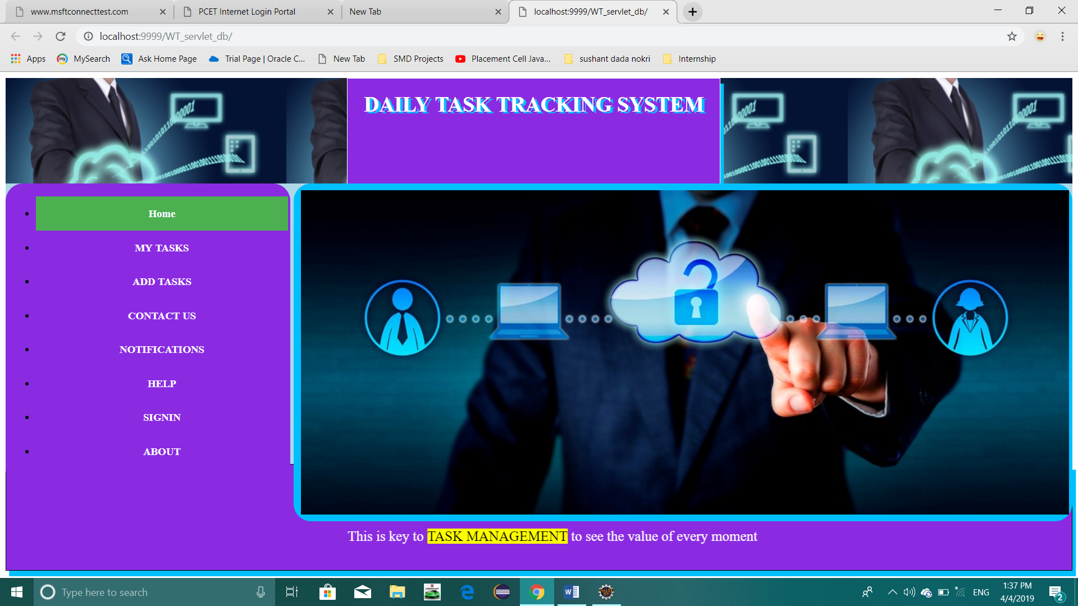

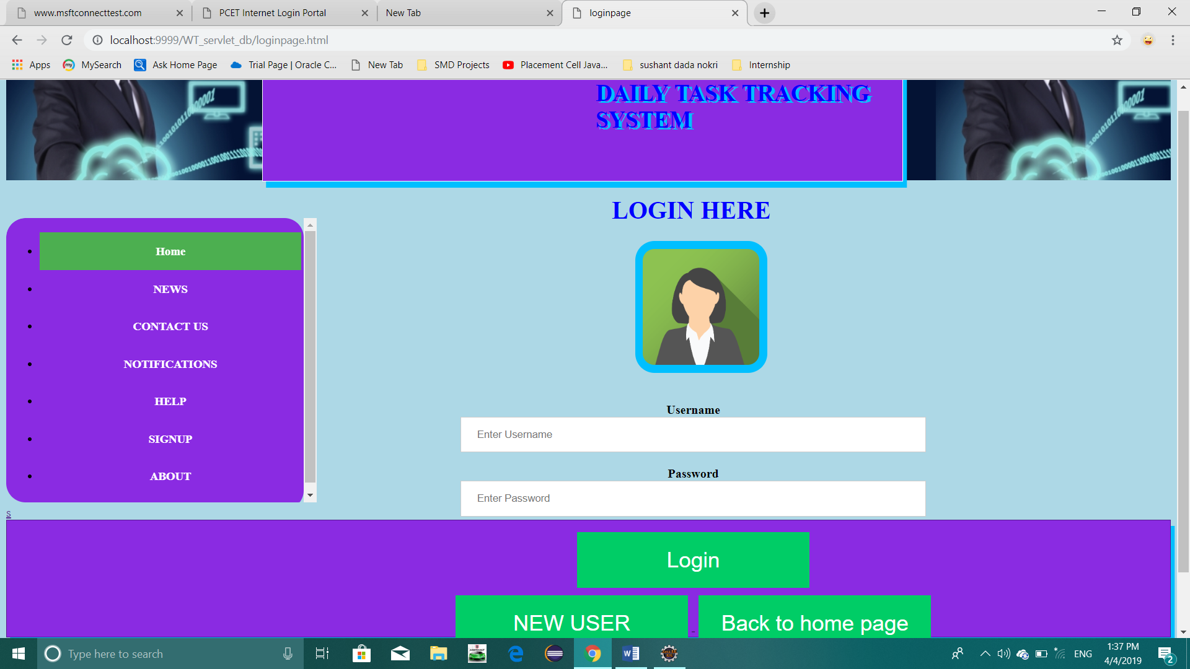

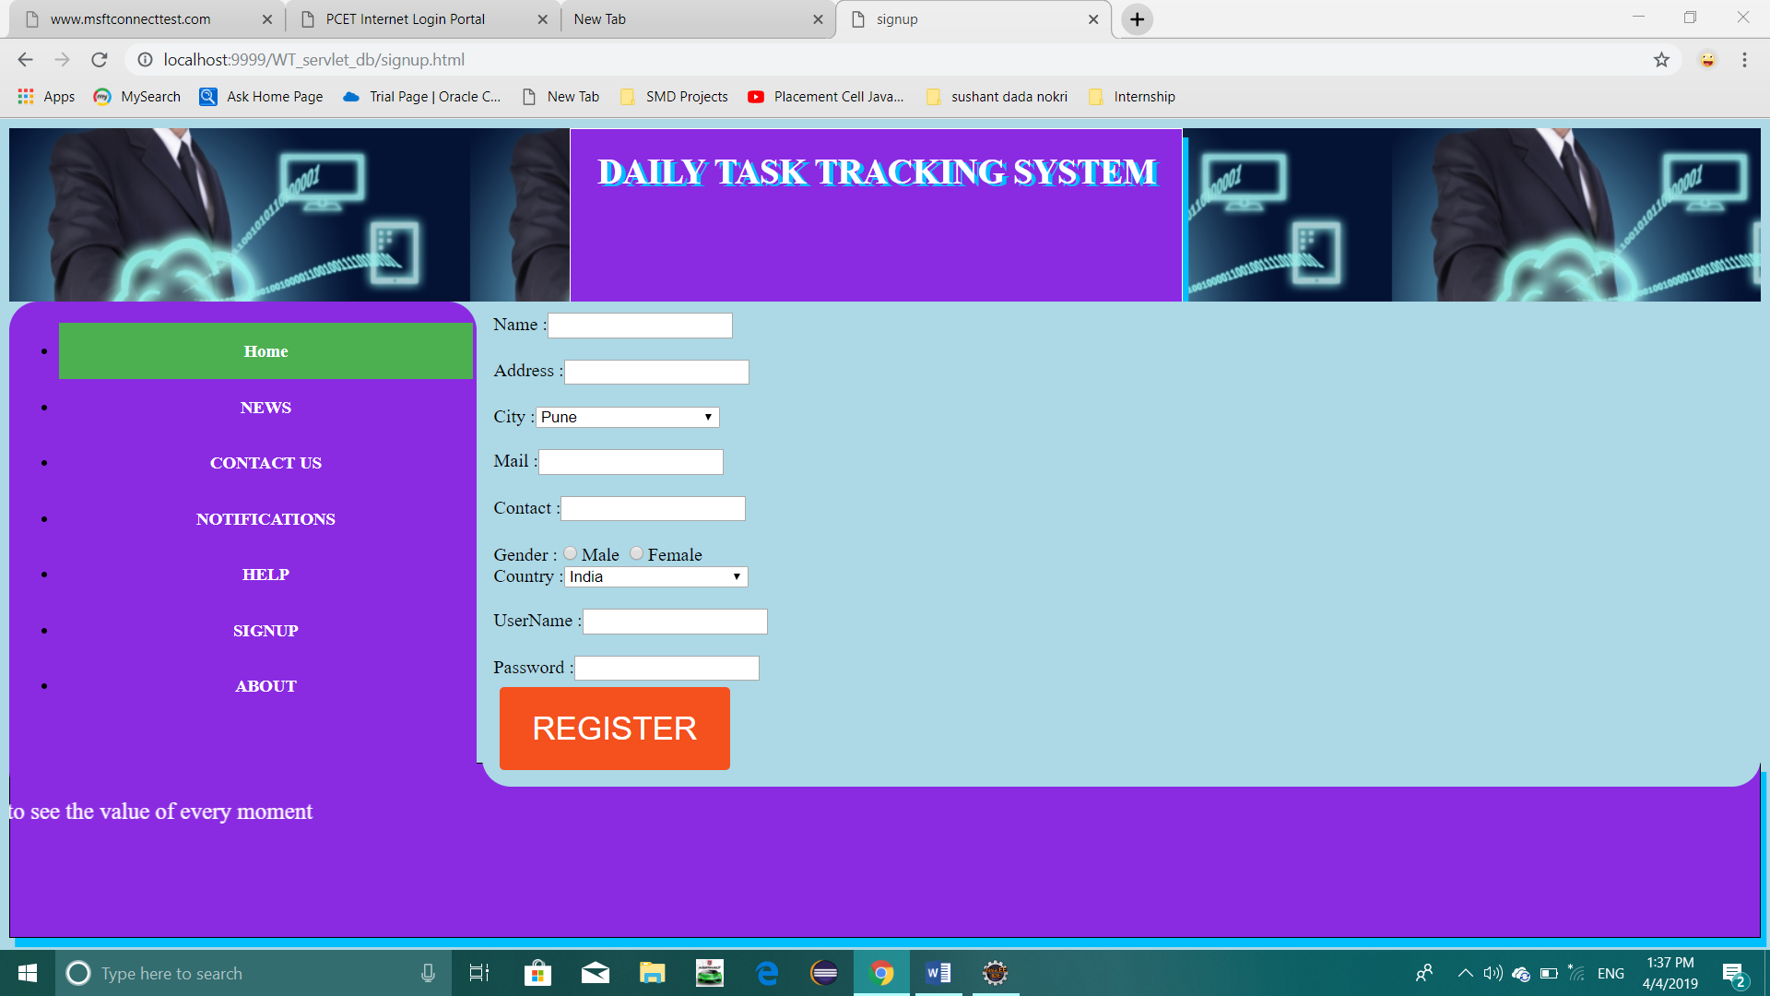

**Chapter 5: CONCLUSION**

So the daily tasks can be organised by using this web based “**DAILY TASK TRACKING SYSTEM”** by prioritising the tasks . It can be smartly used in corporate section for project manager to complete project within time by assigning and tracking allocated work to the employees.